**Convolution and LTI systems**

**LAB # 08**



**Spring 2023**

**CSE301L Signals & Systems Lab**

Submitted by: **Ali Asghar**

Registration No. : **21PWCSE2059**

Class Section: **C**

“On my honor, as student of University of Engineering and Technology, I have neither given nor received unauthorized assistance on this academic work.”

Submitted to:

**Engr. Sumayyea Salahuddin**

Date:

**June 1, 2023**

**Department of Computer Systems Engineering**

**University of Engineering and Technology, Peshawar**

## Lab Objective(s):

Objectives of this Lab are;

* Making Signals Causal and Non‐Causal
* Convolution
* Properties of Convolution

## Task # 01:

Sample the signal given in above example to get its discrete‐time counterpart (take 10 samples/sec as sampling rate). Make the resultant signal causal. Display the lollipop plot of each signal.

**Problem Analysis:**

We can sample a signal in MATLAB.

**Algorithm:**

* Write the code
* Execute it
* Observe the output

**Code:**

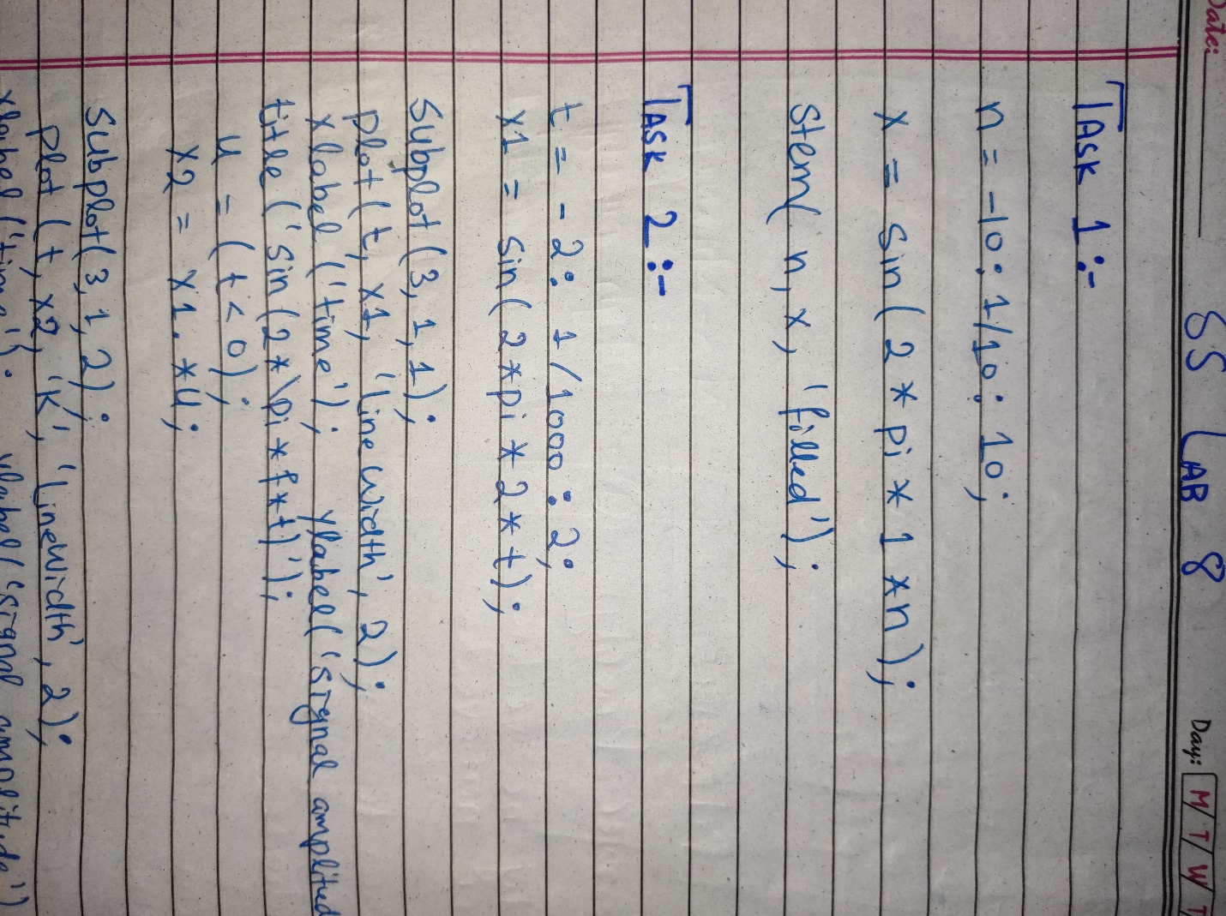

**Output / Graphs / Plots / Results:**

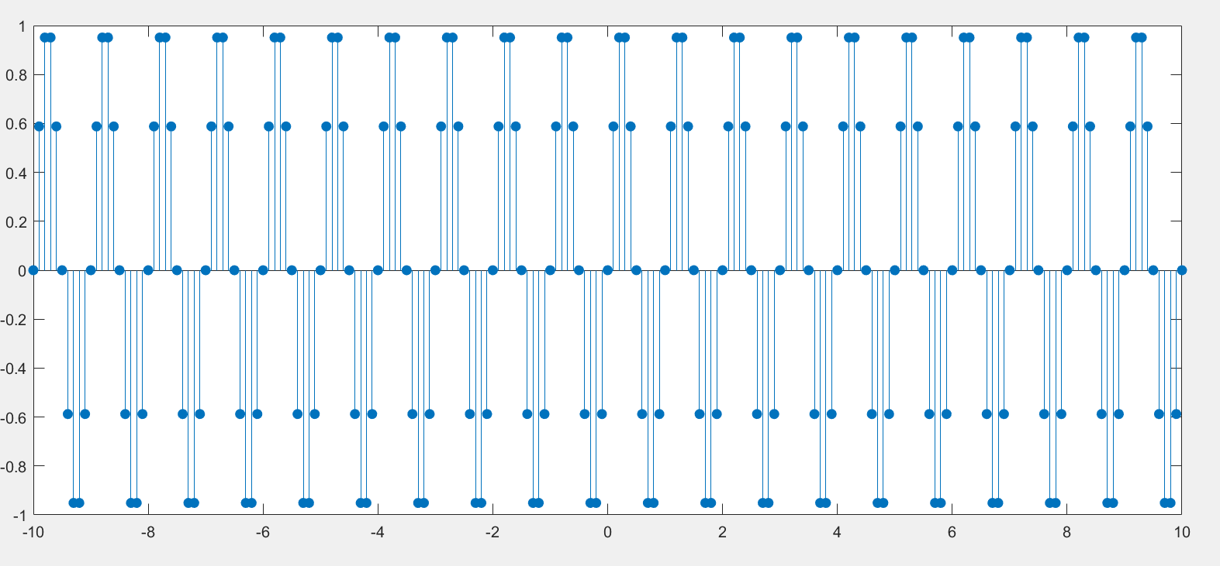

**Discussion and Conclusion:**

We can sample a signal in MATLAB.

## Task # 02:

A signal is said to be anti‐causal if it exists for values of n<0. Make the signal given in above example anti‐causal.

**Problem Analysis:**

We need to make an anti-causal signal in MATLAB.

**Algorithm:**

* Write the code
* Execute it
* Observe the output

**Code:**

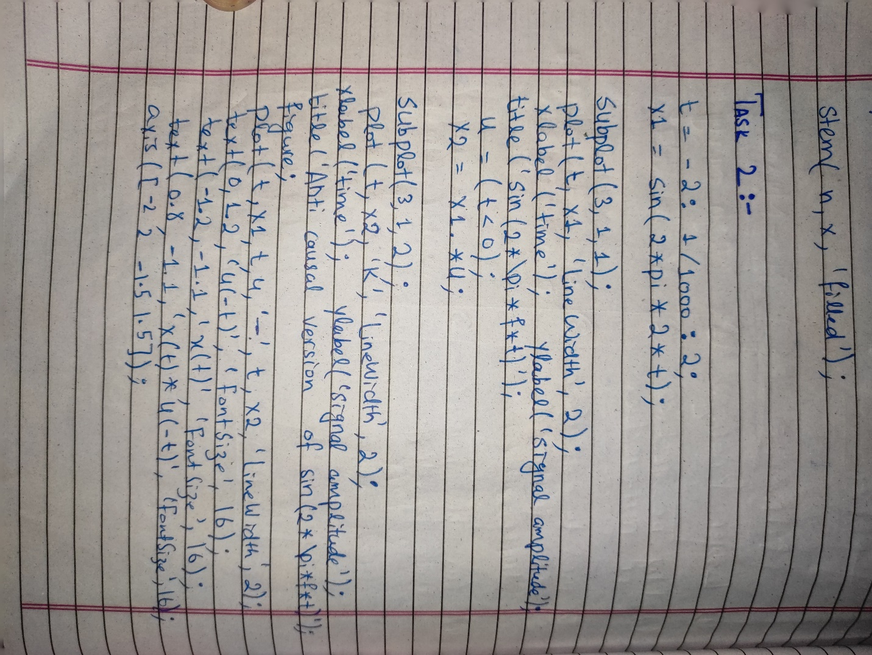

**Output / Graphs / Plots / Results:**

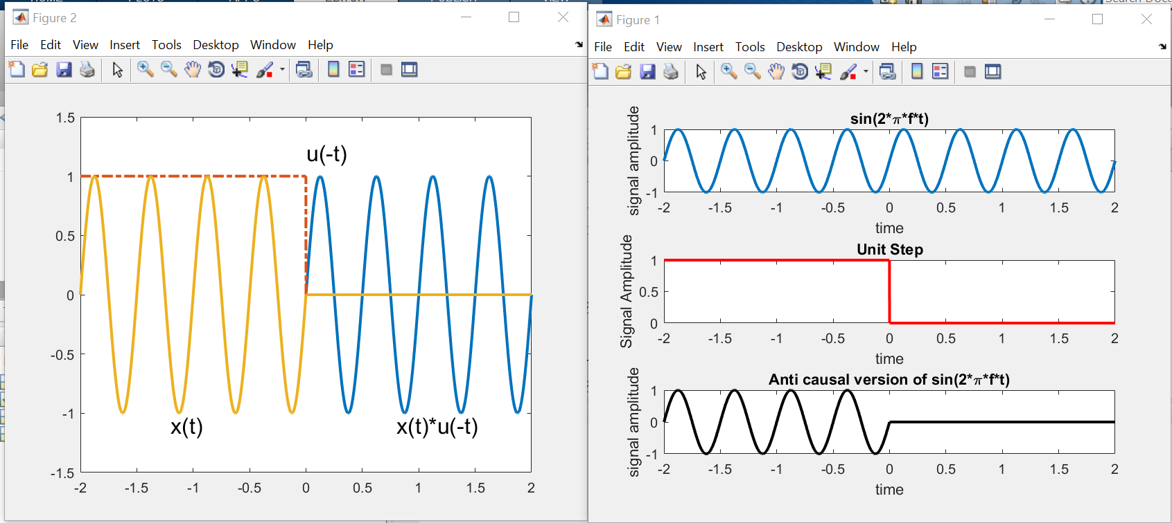

**Discussion and Conclusion:**

We can make an anti-causal signal in MATLAB by using Unit Step Function.

## Task # 03:

Create a function by name of sig_causal in matlab that has two input arguments: (i) a discrete‐time

signal, and (ii) a position vector. The function should make the given signal causal and return the

resultant signal to the calling program.

**Problem Analysis:**

We can perform different operations of signals in MATLAB. Here we make a causal signal than change its causality.

**Algorithm:**

* Write the code
* Execute it
* Observe the output

**Code:**

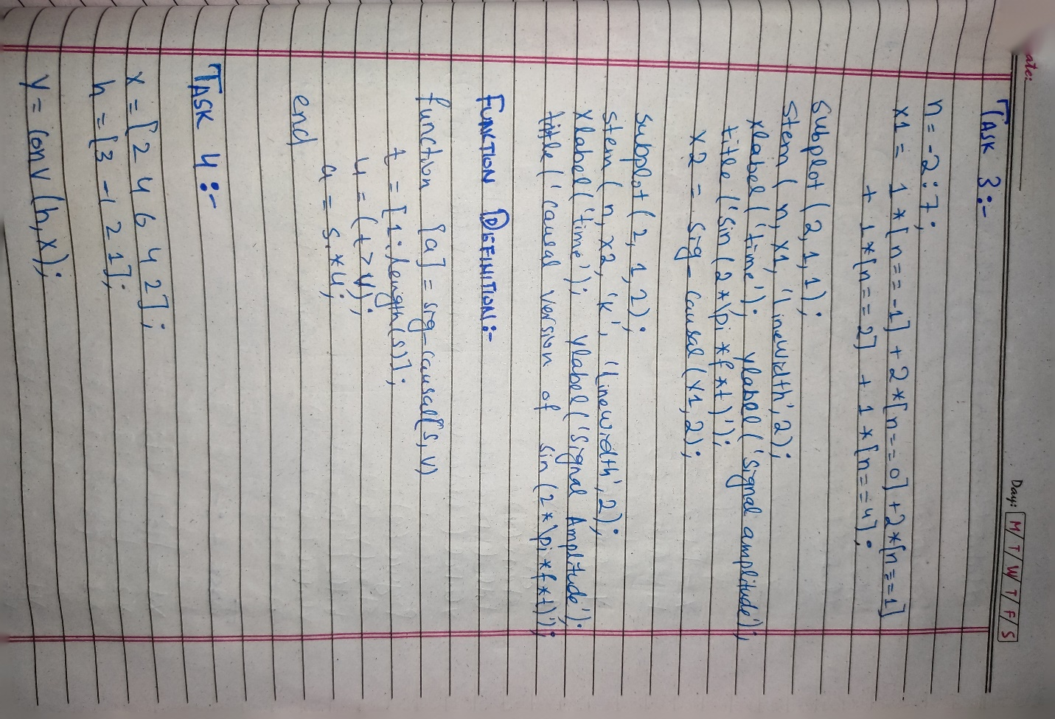

**Output / Graphs / Plots / Results:**

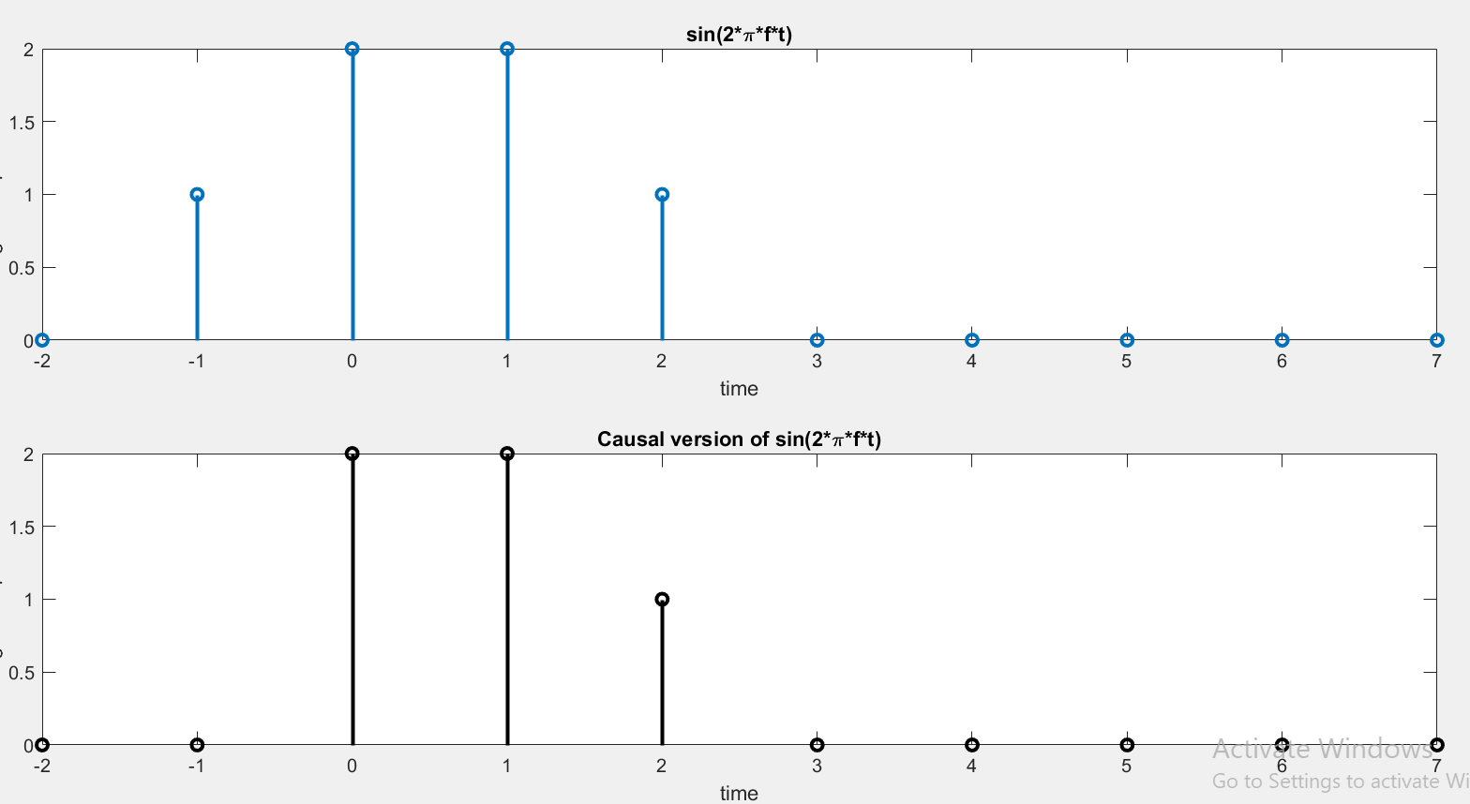

**Discussion and Conclusion:**

We can perform different operations of signals in MATLAB.

## Task # 04:

Convolve the following signals:

x =[2 4 6 4 2];

h =[3 ‐1 2 1];

Plot the input signal as well as the output signal.

**Problem Analysis:**

We can perform different operations of signals in MATLAB. We perform Convolution in MATLAB.

**Algorithm:**

* Write the code
* Execute it
* Observe the output

**Code:**

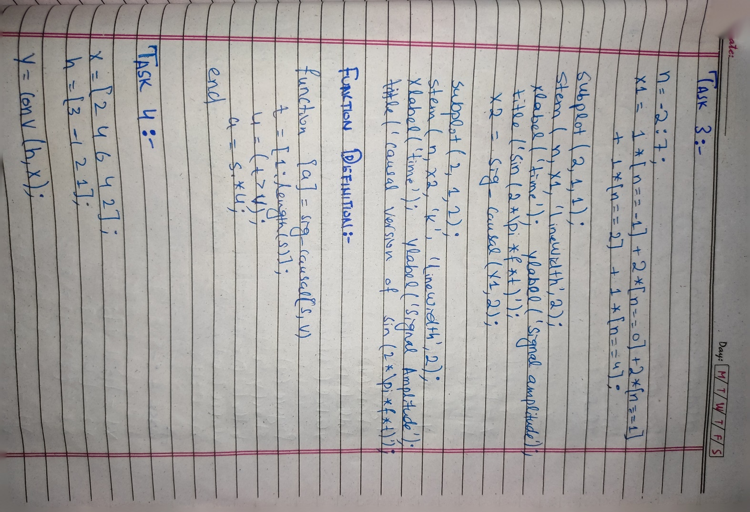

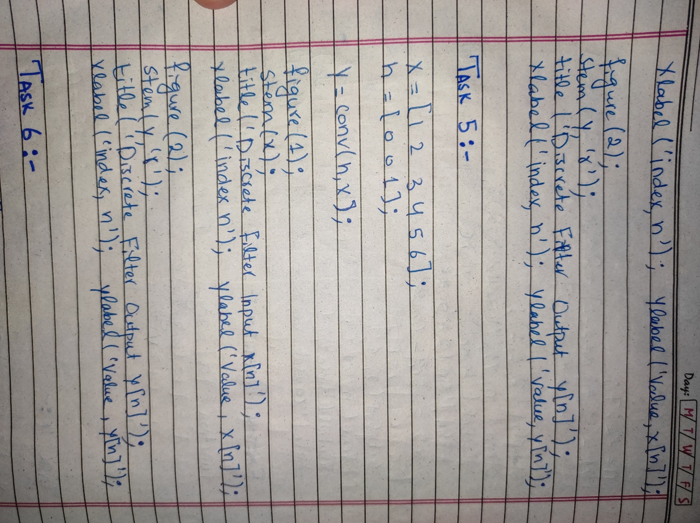

**Output / Graphs / Plots / Results:**

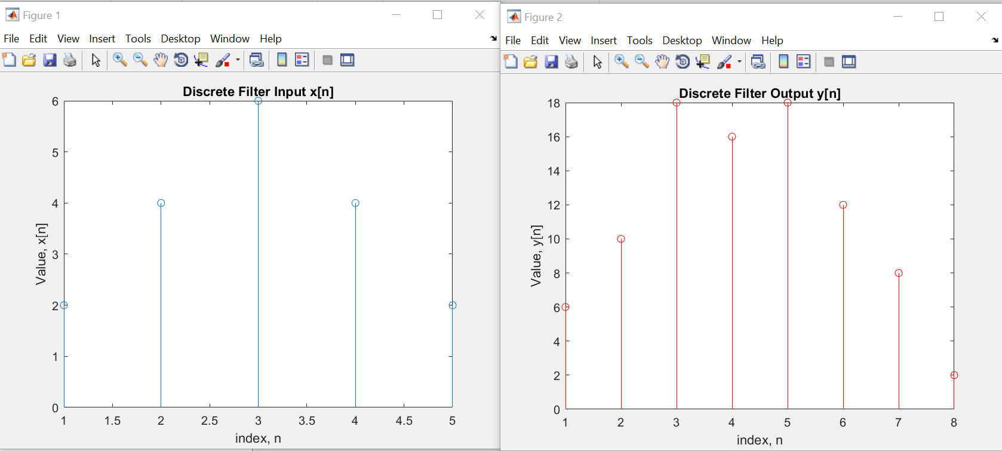

**Discussion and Conclusion:**

We can perform different operations of signals in MATLAB.

## Task # 05:

Convolution is associative. Given the three signal x1[n], x2[n], and x3[n]

As: x1[n]= [3 1 1]

x2[n]= [4 2 1]

x3[n]=[3 2 1 2 3]

Show that (x1[n] * x2[n]) * x3[n] = x1[n] * (x2[n] * x3[n]).

**Problem Analysis:**

We can perform different operations of signals in MATLAB. We perform Convolution in MATLAB.

**Algorithm:**

* Write the code
* Execute it
* Observe the output

**Code:**



**Output / Graphs / Plots / Results:**

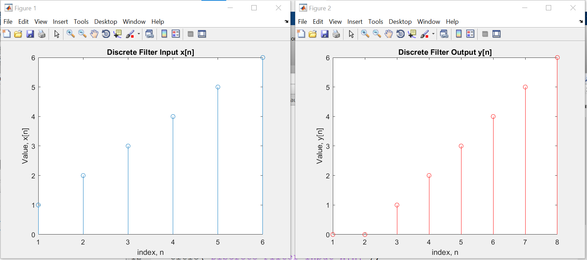

**Discussion and Conclusion:**

We can perform different operations of signals in MATLAB.

## Task # 06:

Convolution is associative. Given the three signal x1[n], x2[n], and x3[n] as:

x1[n]= [3 1 1]

x2[n]= [4 2 1]

x3[n]=[3 2 1 2 3]

Show that (x1[n] * x2[n]) * x3[n] = x1[n] * (x2[n] * x3[n]).

**Problem Analysis:**

We can perform different operations of signals in MATLAB. We perform Convolution in MATLAB.

**Algorithm:**

* Write the code
* Execute it
* Observe the output

**Code:**

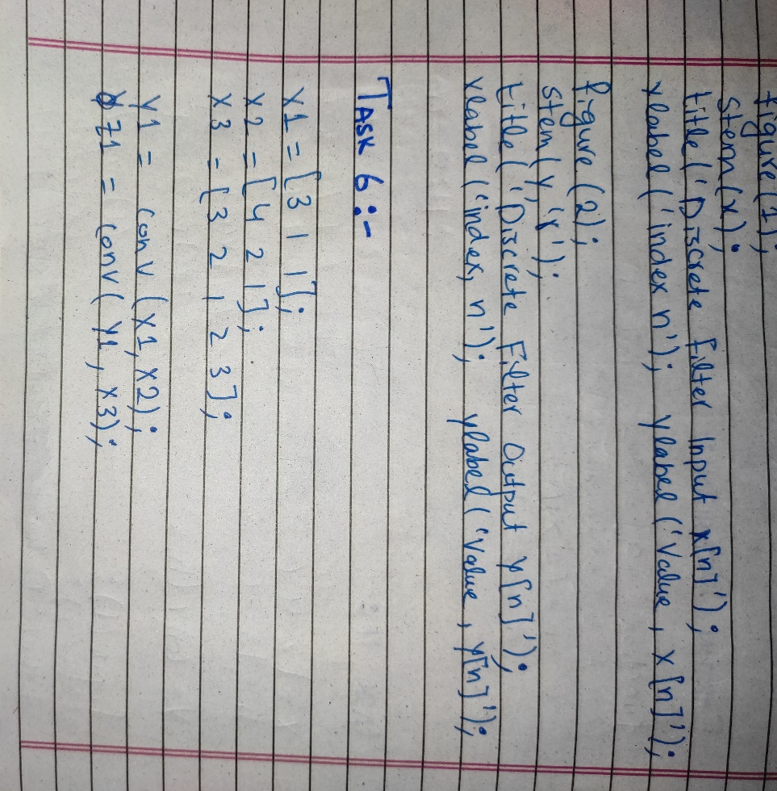

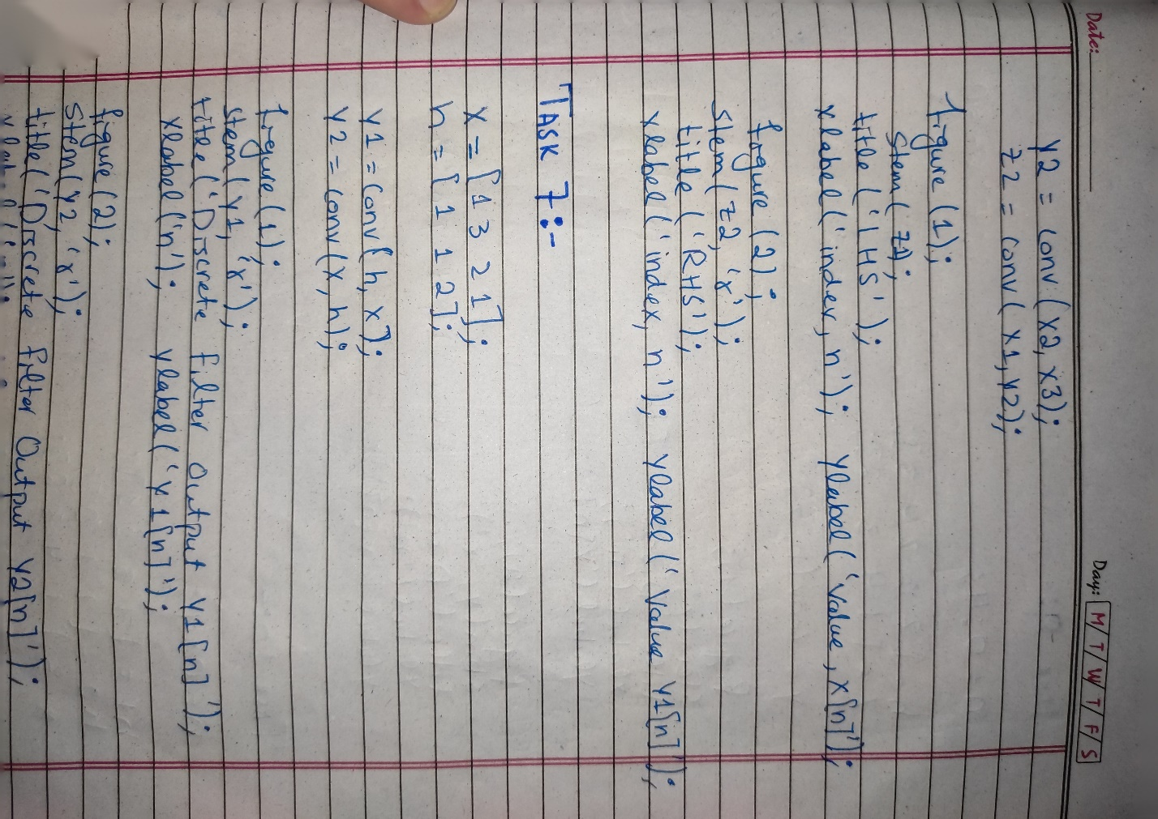

**Output / Graphs / Plots / Results:**

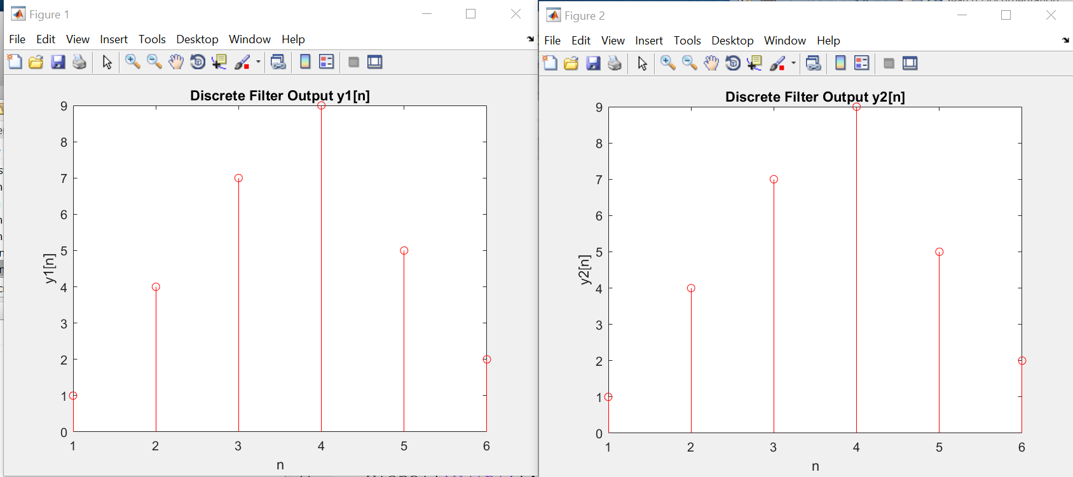

**Discussion and Conclusion:**

We can perform different operations of signals in MATLAB.

## Task # 07:

Convolution is commutative. Given x[n] and h[n] as: X[n]=[1 3 2 1] H[n]=[1 1 2]

Show that x[n] * h[n] = h[n] * x[n].

**Problem Analysis:**

We need to show that Convolution is commutative.

**Algorithm:**

* Write the code
* Execute it
* Observe the output

**Code:**

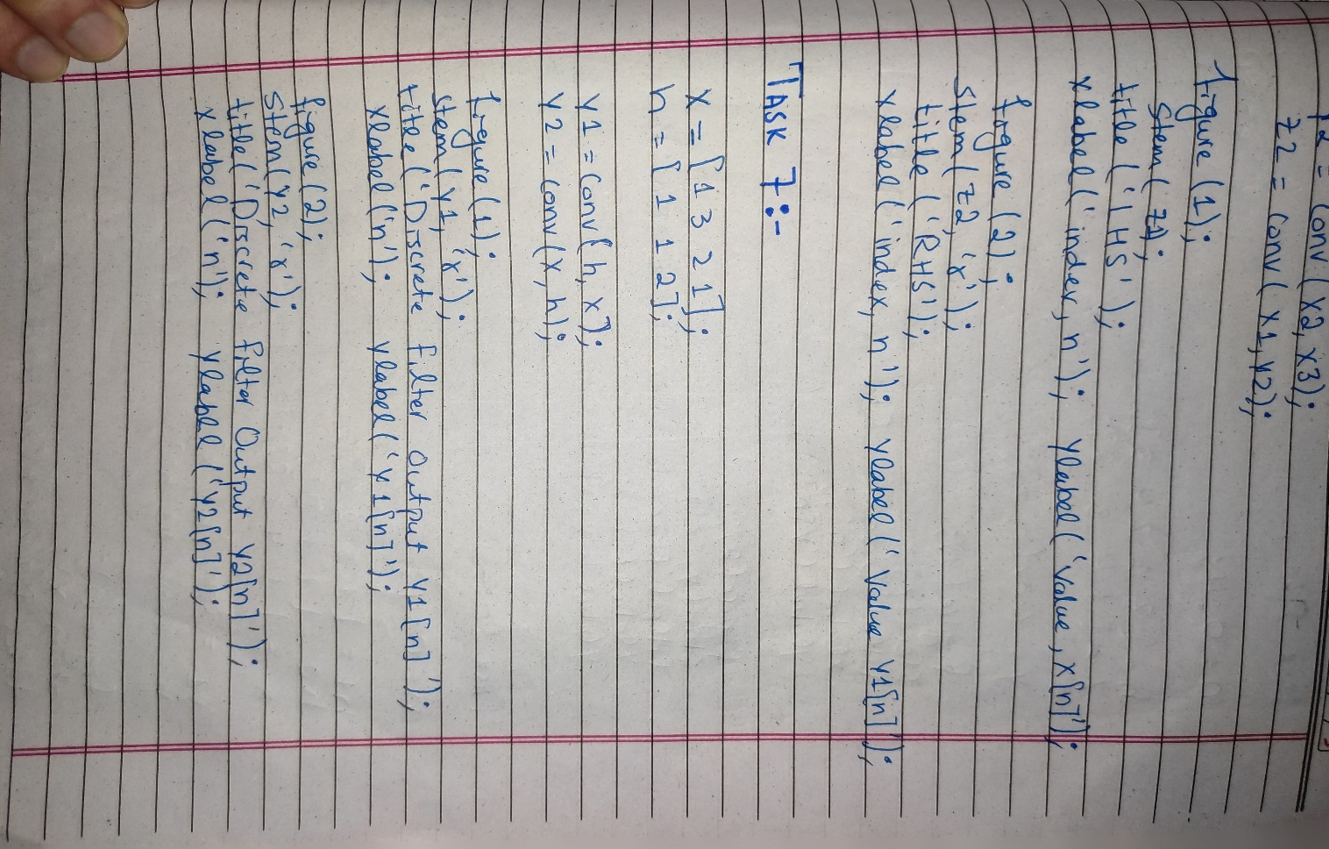

**Output / Graphs / Plots / Results:**

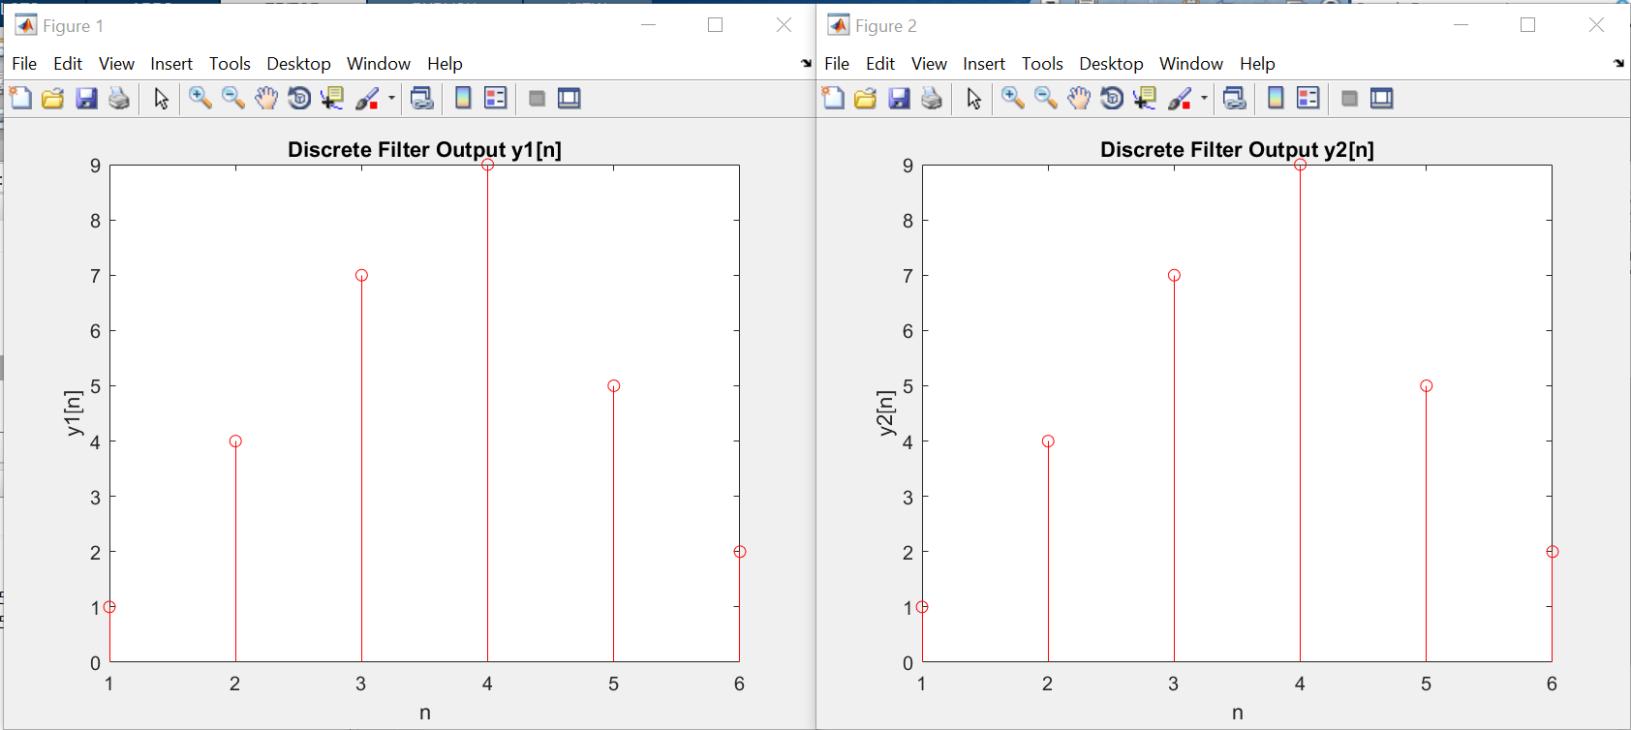

**Discussion and Conclusion:**

We can perform different operations of signals in MATLAB.

## Task # 08:

Determine h[n] for the system:

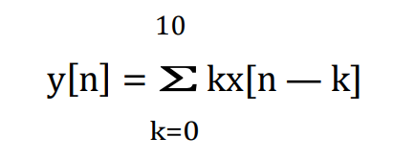

When x[n] = 2δ[n]. Plot the input signal, impulse response, and output signal.

**Problem Analysis:**

We can perform different operations of signals in MATLAB. We perform Convolution in MATLAB.

**Algorithm:**

* Write the code
* Execute it
* Observe the output

**Code:**

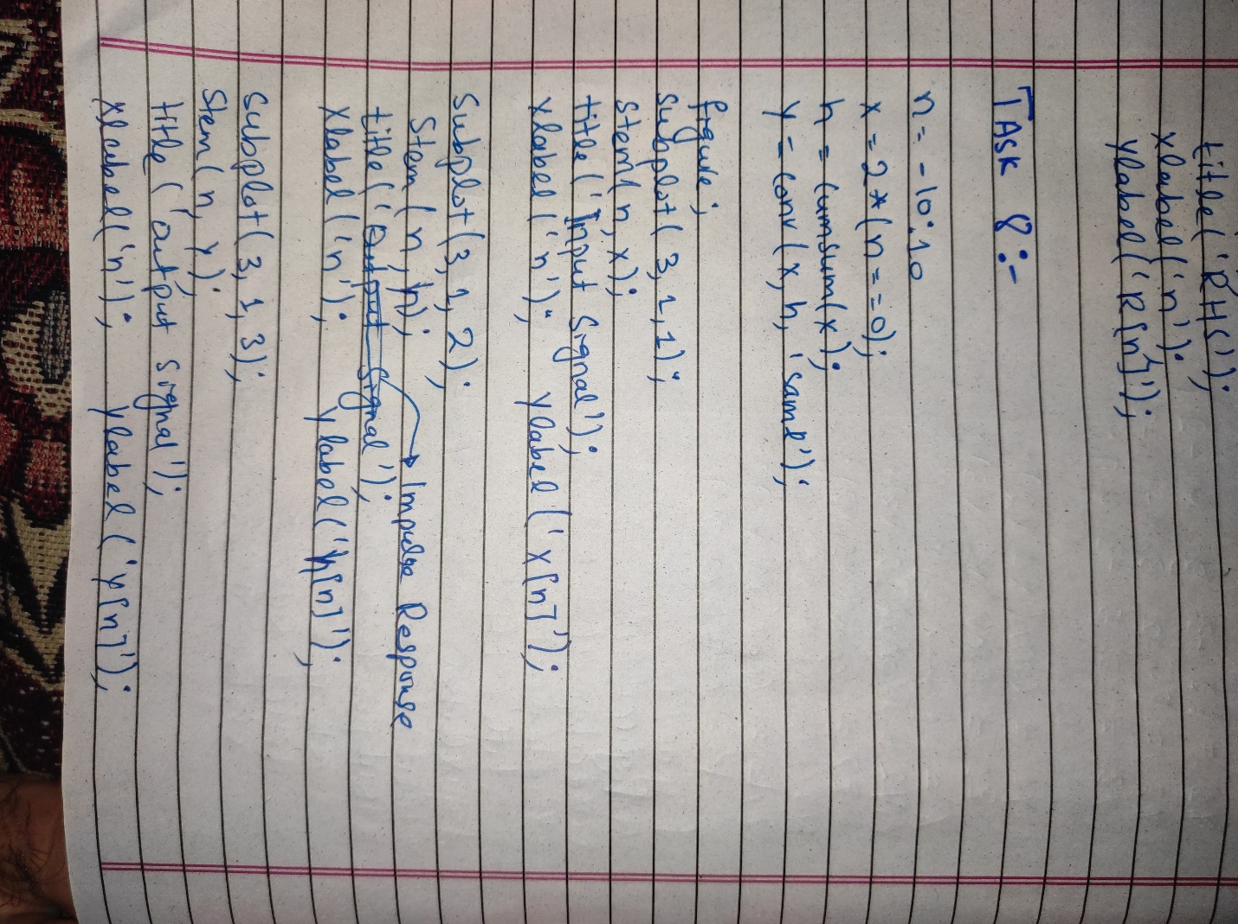

**Output / Graphs / Plots / Results:**

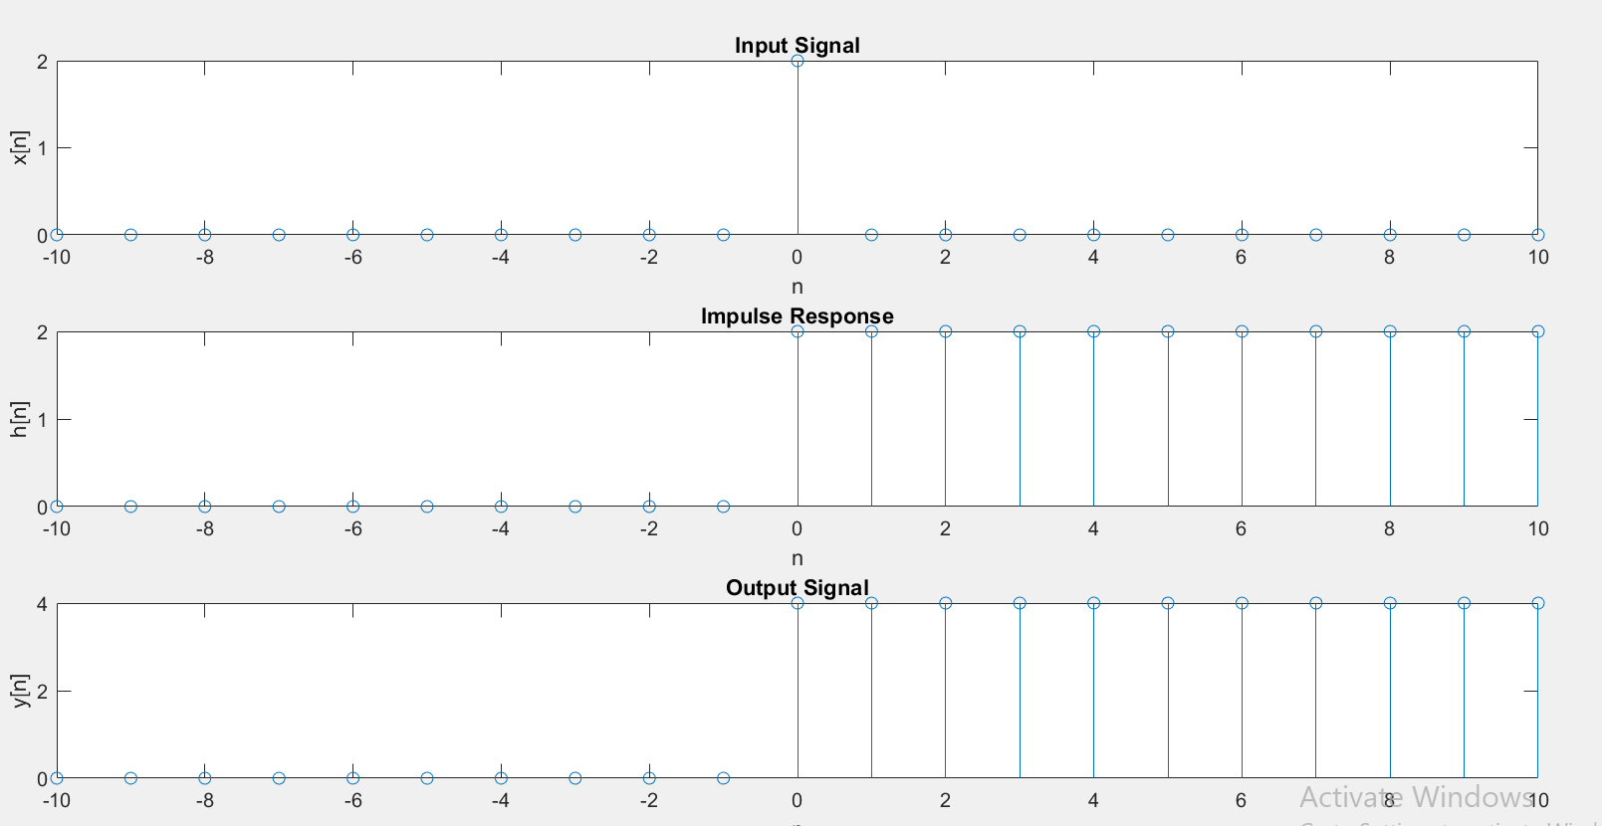

**Discussion and Conclusion:**

We can perform different operations of signals in MATLAB.

## Task # 09:

Given the impulse response of the systems as: h[n]= 2δ[n] + δ[n‐1]+ 2δ[n‐2]+ 4δ[n‐3]+ 3δ[n‐4] If the input x[n] = δ[n]+ 4δ[n‐1] +3δ[n‐2] + 2δ[n‐3] is applied to the system, determine the output of the system.

**Problem Analysis:**

We can perform different operations of signals in MATLAB. We perform Convolution in MATLAB.

**Algorithm:**

* Write the code
* Execute it
* Observe the output

**Code:**

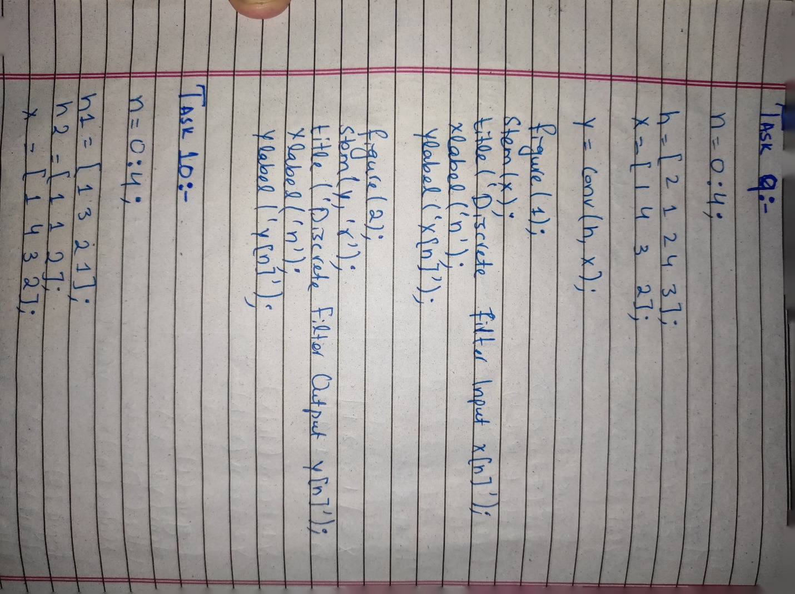

**Output / Graphs / Plots / Results:**

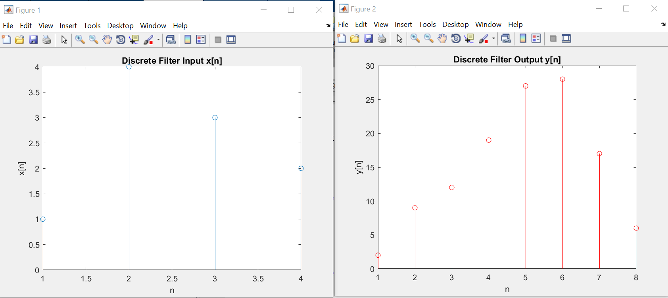

**Discussion and Conclusion:**

We can perform different operations of signals in MATLAB.

## Task # 10:

Two systems are connected in cascade:

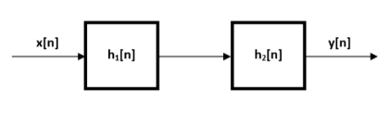

h1[n]=[1 3 2 1]

h2[n]=[1 1 2]

If the input x[n] = δ[n]+ 4δ[n‐1] +3δ[n‐2] +2δ[n‐3] is applied, determine the output.

**Problem Analysis:**

We can perform different operations of signals in MATLAB. We perform Convolution in MATLAB.

**Algorithm:**

* Write the code
* Execute it
* Observe the output

**Code:**

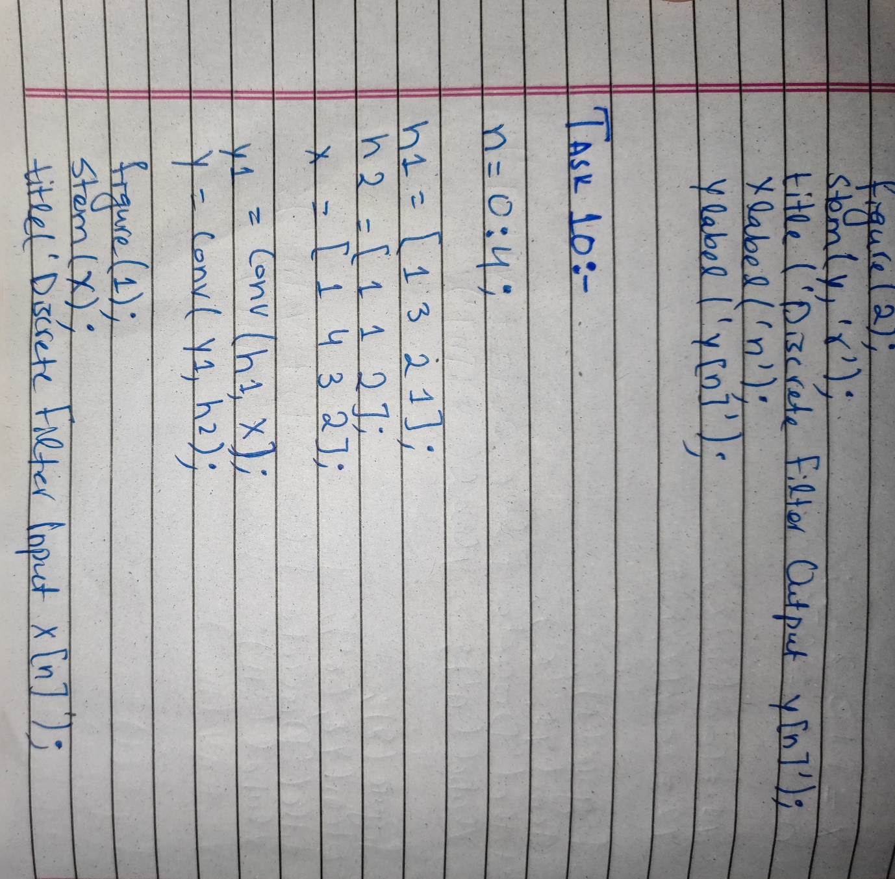

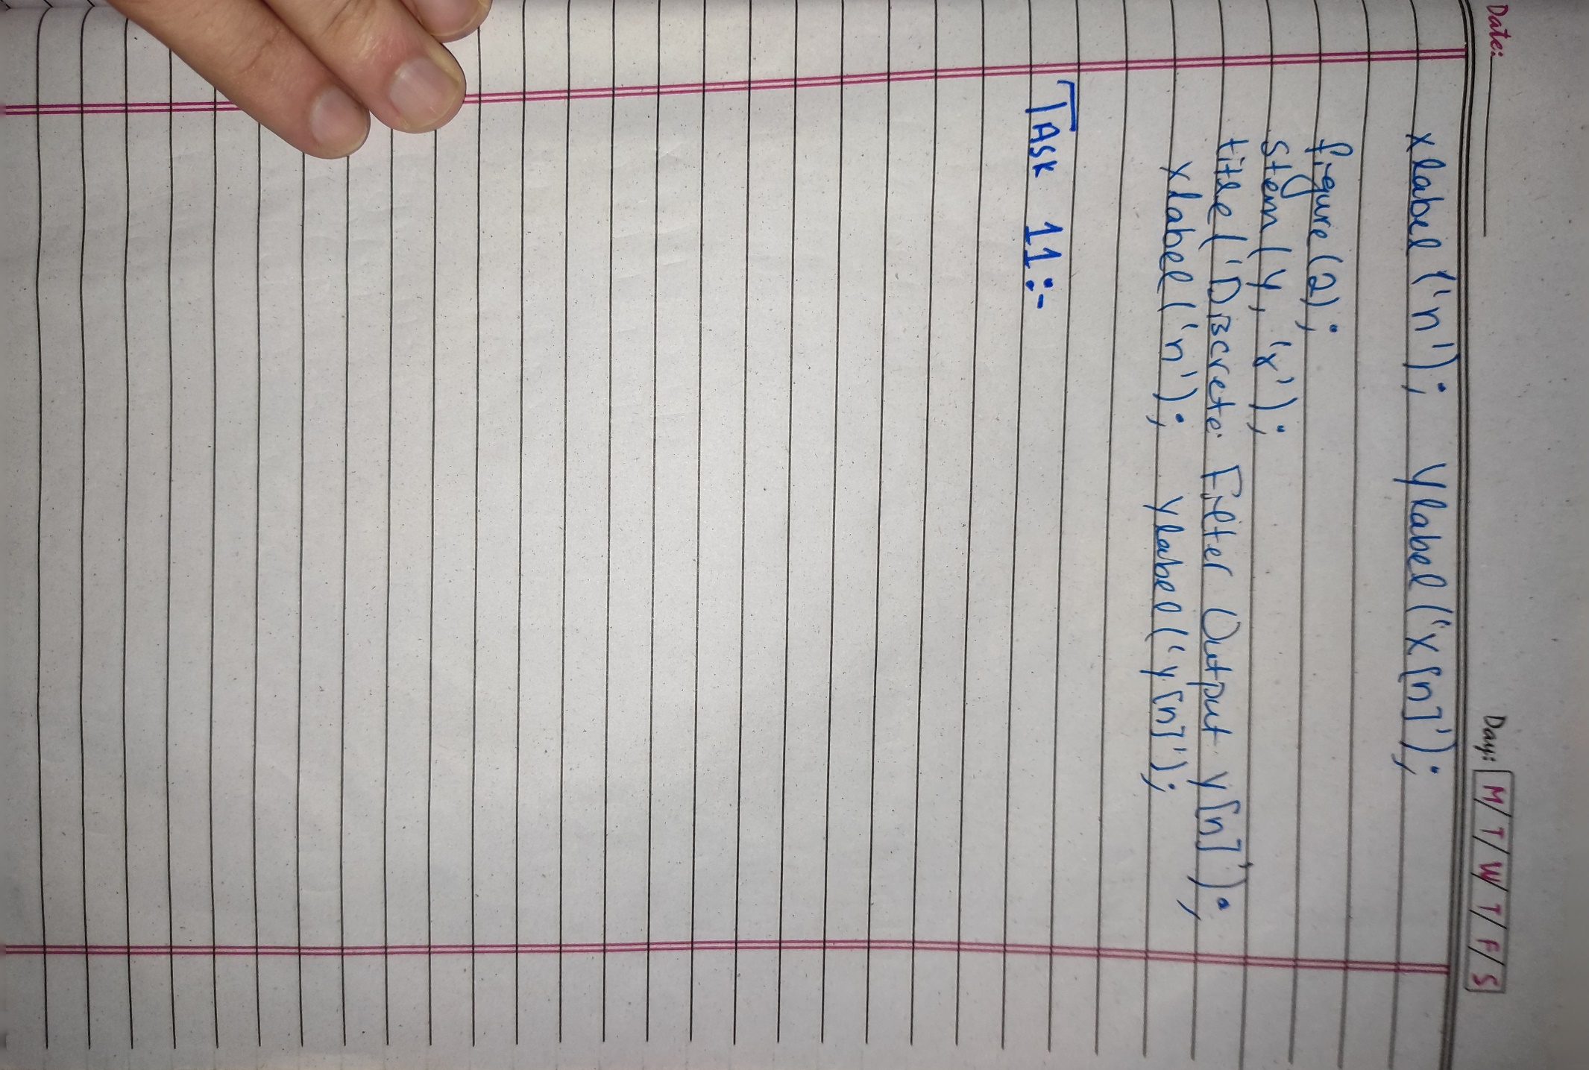

**Output / Graphs / Plots / Results:**

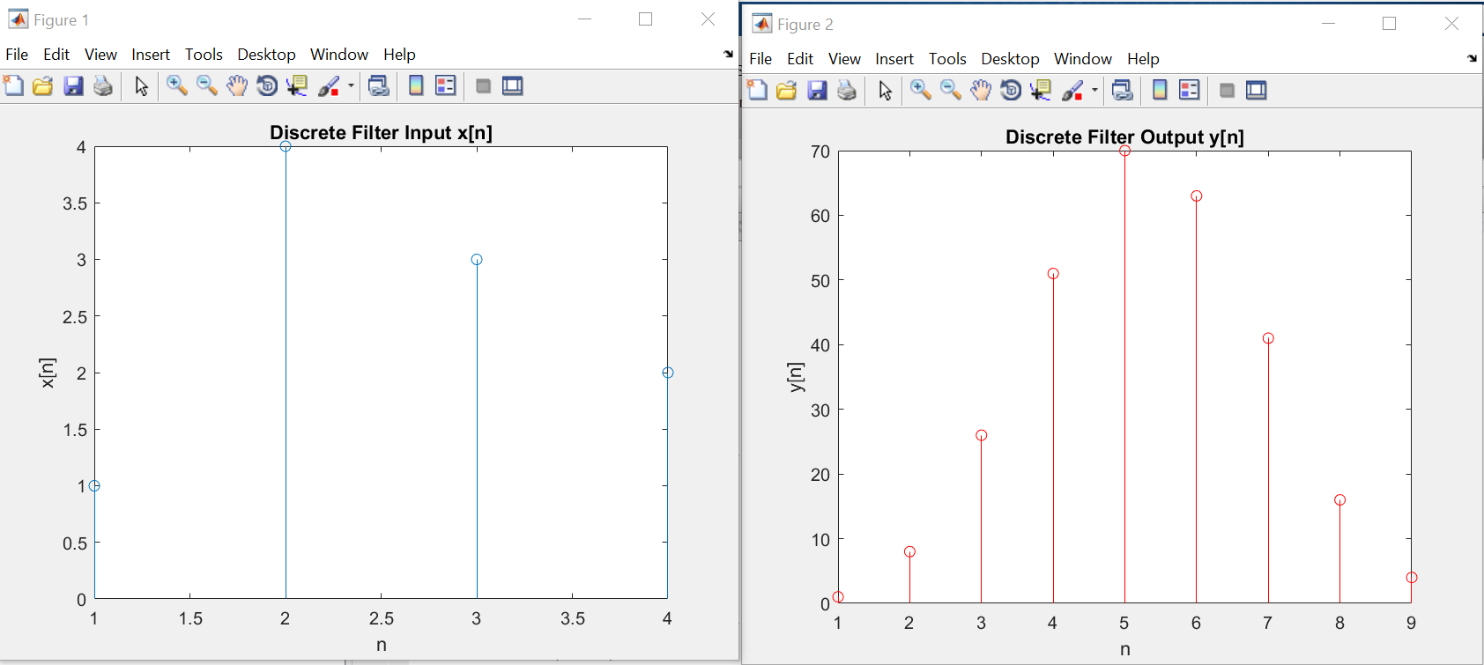

**Discussion and Conclusion:**

We can perform different operations of signals in MATLAB.

## Task # 11:

Given the signals:

x1[n]= 2δ[n] ‐3δ[n‐1]+ 3δ[n‐2] +4δ[n‐3] ‐2δ[n‐4]

x2[n]= 4δ[n]+ 2δ[n‐1]+ 3δ[n‐2] ‐ δ[n‐3] ‐2δ[n‐4]

x3[n]= 3δ[n]+ 5δ[n‐1]‐3δ[n‐2] +4 δ[n‐3]

Verify that

x1[n] * (x2[n] * x3[n]) = (x1[n] * x2[n]) * x3[n]

x1[n] * x2[n]= x2[n] * x1[n]

**Problem Analysis:**

We can perform different operations of signals in MATLAB. We perform Convolution in MATLAB.

**Algorithm:**

* Write the code
* Execute it
* Observe the output

**Code:**

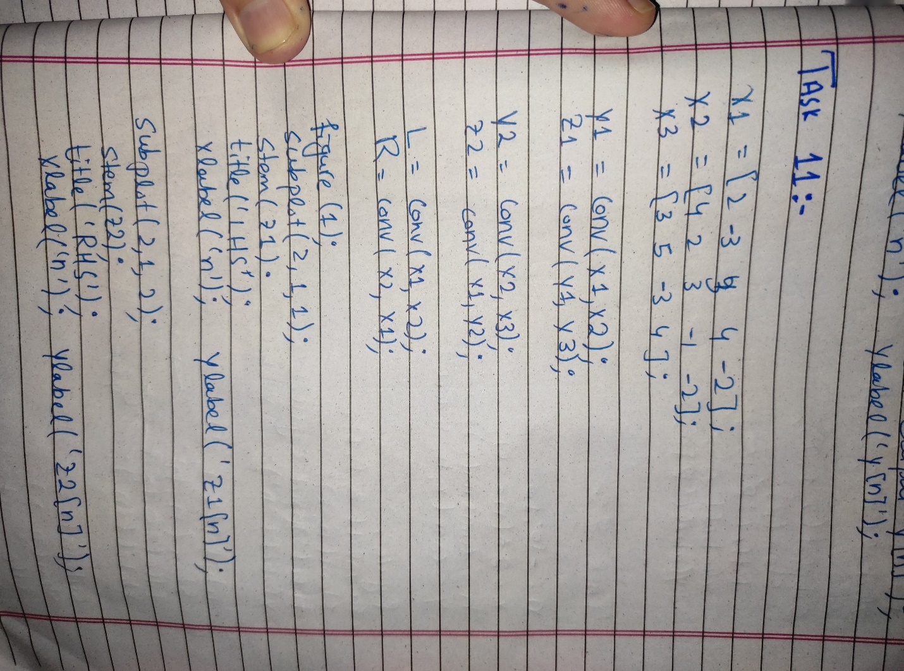

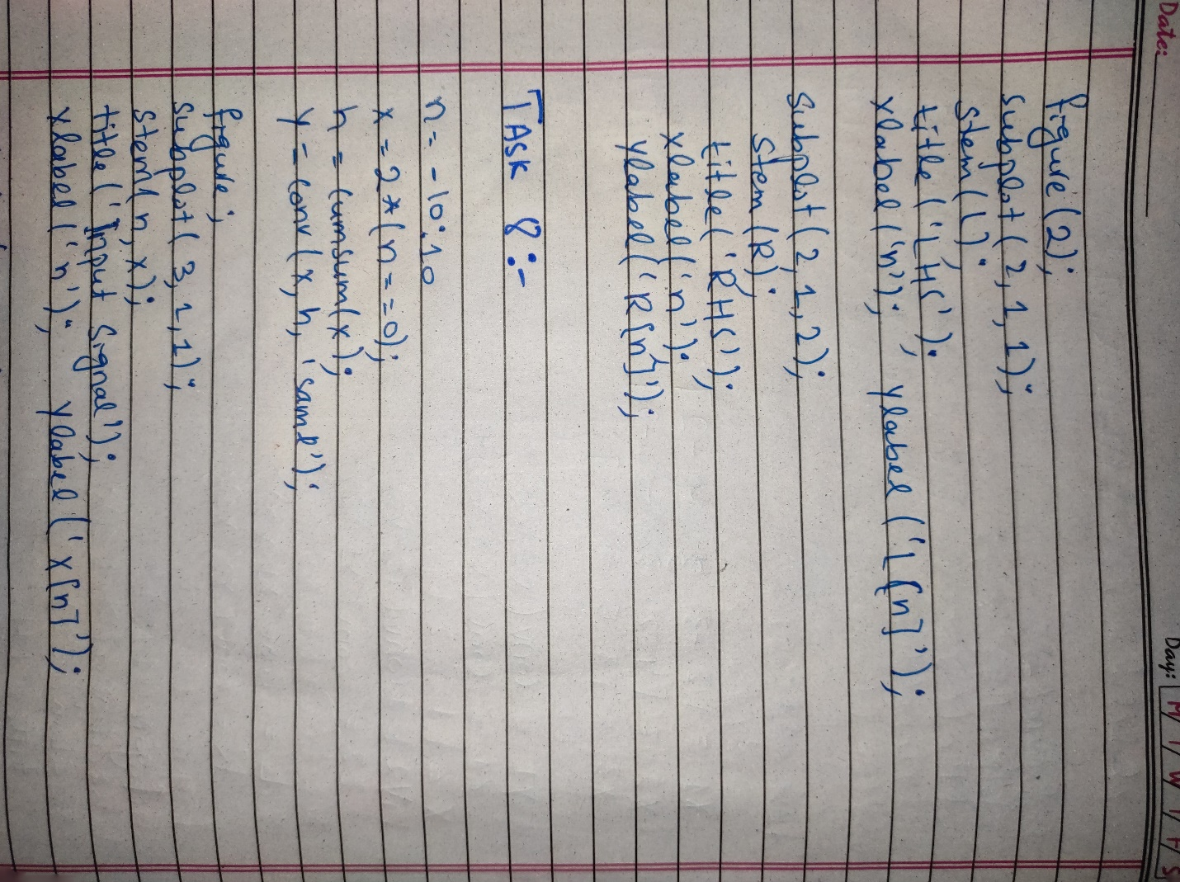

**Output / Graphs / Plots / Results:**

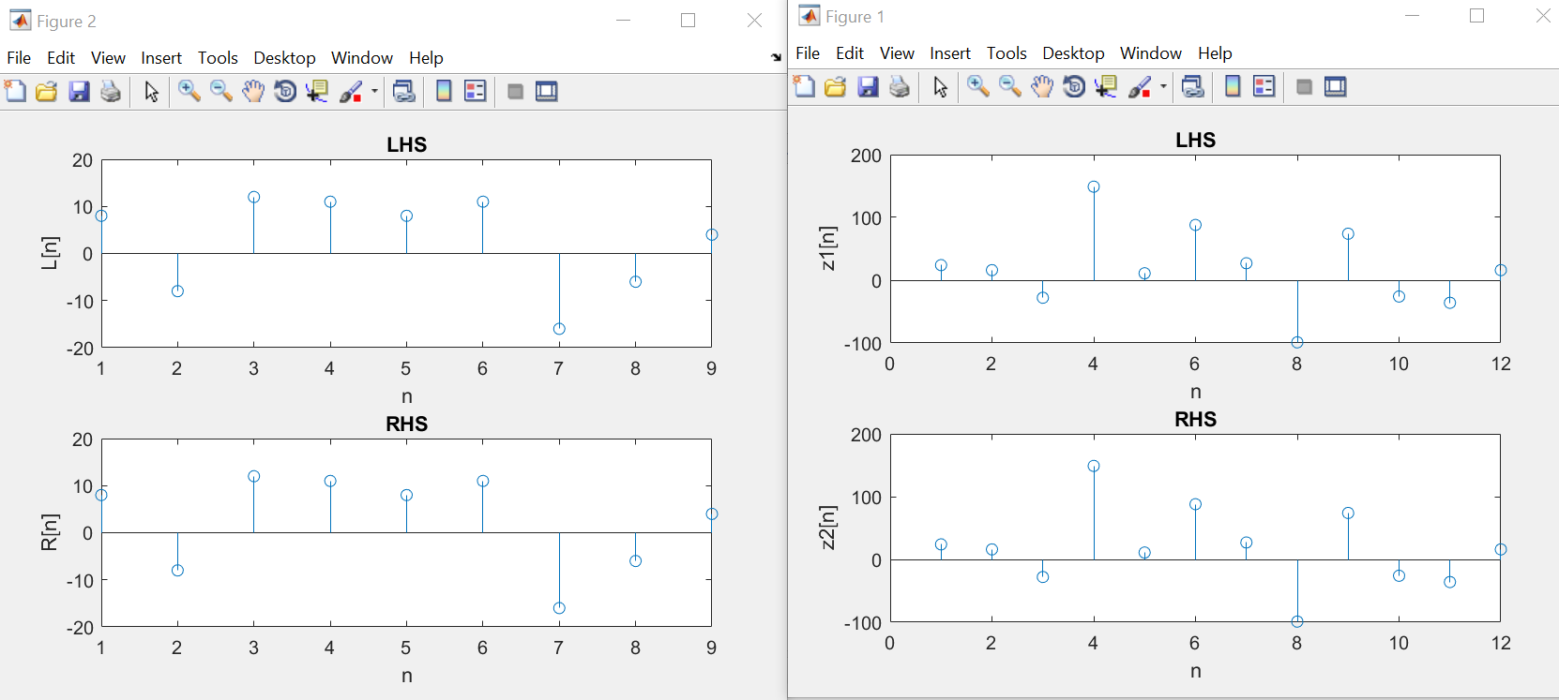

**Discussion and Conclusion:**

We can verify different convolution properties in MATLAB.